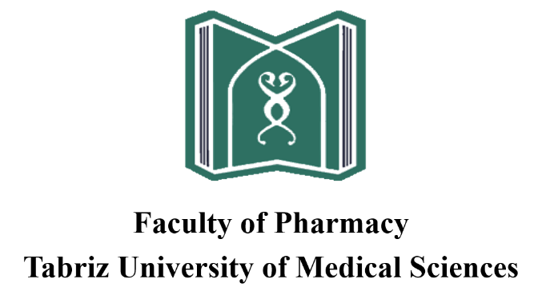

**Pharmaceutical Chemistry Courses (M.Sc.)**

**Course specification of the educational program of the master's course in the field of pharmaceutical chemistry**

1) Name and definition of the field and related section:

Pharmaceutical chemistry (M.Sc.)

2) Length of period and structure:

In accordance with the educational regulations of the postgraduate course of discontinuous approved by the Supreme Council of Medical Sciences Planning

3) Total number of courses:

The number of courses in this course is 32 units, which are as follows:

*Compulsory Dedicated Units:21 units

*Optional Dedicated Units: 5 units

*Thesis: 6 units

Note: The student is required to pass all or a number of deficient or compensatory courses in addition to passing the courses with the recognition of the department and the approval of the Graduate Council of the University

|  |  |  |  |  |  |  |  |  |  |  |
| --- | --- | --- | --- | --- | --- | --- | --- | --- | --- | --- |
| Course code | Course name | Number of courses | | | | Number of Lesson Hours | | | | Prerequisite |
| Total | Practical | Theoretical | Internship | Total | Practical | Theoretical | Internship |
| 01 | Biology | 2 | _ | 2 | _ | 34 | _ | 34 | _ | _ |
| 02 | Statistics and Pharmaceutical Information Systems | 2 | 1 | 1 | _ | 51 | 34 | 17 | _ | _ |
| 03 | Physiology | 3 | _ | 3 | _ | 51 | _ | 51 | _ | _ |
| 04 | Biochemistry | 3 | _ | 3 | _ | 51 | _ | 51 | _ | _ |
| 05 | Medical Information Systems* | 1 | .05 | .05 | _ | 26 | 17 | 9 | _ | _ |
| Total | | 11 | | | | | | | | |

table A): Deficient or compensatory courses of the postgraduate course of Medicinal Chemistry:

* Passing this course is mandatory as a deficient or compensatory course for all students.

|  |  |  |  |  |  |  |  |  |  |  |
| --- | --- | --- | --- | --- | --- | --- | --- | --- | --- | --- |
| Lesson code | Name of Course | number of courses | | | | Number of Lesson Hours | | | | Prerequisite or simultaneous |
| Total | Practical | Theoretical | Internship | Total | Practical | Theoretical | Internship |
| 05 | Basics of synthesis | 3 | 1 | 2 | _ | 68 | 34 | 34 | ______ | _______ |
| 06 | Pharmacology | 3 | _ | 3 | _ | 51 | _ | 51 | ______ | 03&04 |
| 07 | Medicinal chemistry 1 | 2 | _ | 2 | _ | 34 | _ | 34 | ______ | 06 |
| 08 | Medicinal chemistry 2 | 2 | _ | 2 | _ | 34 | _ | 34 | ______ | 07 |
| 09 | Instrumental chemistry | 4 | 1 | 3 | _ | 85 | 34 | 51 | ______ | ______ |
| 10 | Heterocyclic Chemistry | 3 | _ | 3 | _ | 51 | _ | 51 | _______ | ______ |
| 11 | Computational chemistry of drug design | 3 | _ | 3 | _ | 51 | _ | 51 | ______ | ______ |
| 12 | Seminar | 1 | _ | 1 | _ | 17 | _ | 17 | ______ | _______ |
| 13 | Thesis | 6 | | | | | | | | |
| Total | | 27 | | | | | | | | |

Table B) Dedicated lessons Educational program of the non-continuous master's course in the field of medicinal chemistry

*Table C) Table of special-optional courses Educational program of the non-continuous master's course in the field of medicinal chemistry*

|  |  |  |  |  |  |  |  |  |  |  |
| --- | --- | --- | --- | --- | --- | --- | --- | --- | --- | --- |
| Lesson code | Name of Course | number of courses | | | | Number of Lesson Hours | | | | Prerequisite or simultaneous |
| Total | Practical | Theoretical | Intern ship | Total | Practical | Theoretical | Internship |  |
| 14 | Chemistry of natural compounds | 2 | ______ | 2 | _____ | 34 | ____ | 34 | _____ | _____ |
| 15 | Medicinal chemistry and nanotechnology | 3 | _____ | 3 | _____ | 51 | ____ | 51 | _____ | ______ |
| 16 | Biological tests | 3 | 1 | 3 | _____ | 68 | 34 | 34 | _____ | ______ |
| 17 | Radio pharmacy | 2 | _____ | 2 | _____ | 34 | ____ | 34 | _____ | ______ |
| 18 | Basics of biotechnology | 2 | _____ | 2 | _____ | 34 | _____ | 34 | _____ | ______ |
| Total | | 12 | | | | | | | | |

The student must complete 5 units of the above courses according to the topic of the thesis, with the approval of the supervisor and the approval of the graduate education council of the university.